**2.1: Getting Started with Django**

1. *Write two to three sentences on why Django is so popular among web developers.*

Web developers love Django because it helps them work faster and smarter. It has lots of useful tools and features built-in, saving them time and effort. Plus, Django promotes clean and organized code, making it easier to build and maintain websites.

1. *After some research, list five large companies that use Django. Specify what the company’s product or service is and what they use Django for.*

Here are five big companies that use Django, along with simple descriptions of what they do and how they use Django:

1. ***Instagram:*** Instagram is a photo and video-sharing social media platform. They use Django to create and maintain their website.
2. ***Pinterest:*** Pinterest is a platform for discovering and saving ideas. They rely on Django for their website's backend, including user authentication and storing content.
3. ***Spotify:*** Spotify is a music streaming service. While they use other technologies primarily, they use Django for internal tools and managing content.
4. ***Mozilla:*** Mozilla is the organization behind the Firefox web browser. They use Django for building web applications, APIs, and internal tools.
5. ***Dropbox:*** Dropbox is a cloud storage and file hosting service. Django helps them with user authentication, storing files, and enabling collaboration features.
6. *For each of the following scenarios, explain if you would use Django (and why or why not):*
   * *You need to develop a web application with multiple users.*

Yes, Django is a good choice. It helps manage multiple users and keeps things secure.

* + *You need fast deployment and the ability to make changes as you proceed.*

Yes, Django is good for that. It allows quick development and easy modifications.

* + *You need to build a very basic application, which doesn’t require any database access or file operations.*

No, Django may not be the best fit. It's more focused on managing databases and files.

* + *You want to build an application from scratch and want a lot of control over how it works.*

Yes, Django is suitable. It gives you control and flexibility to customize the application.

* + *You’re about to start working on a big project and are afraid of getting stuck and needing additional support.*

Yes, Django is a good choice. It has a large community and resources available for support.

1. *Python:*

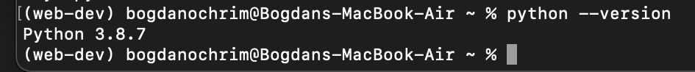

1. *Virtual Environment:*

1. *Django:*

**